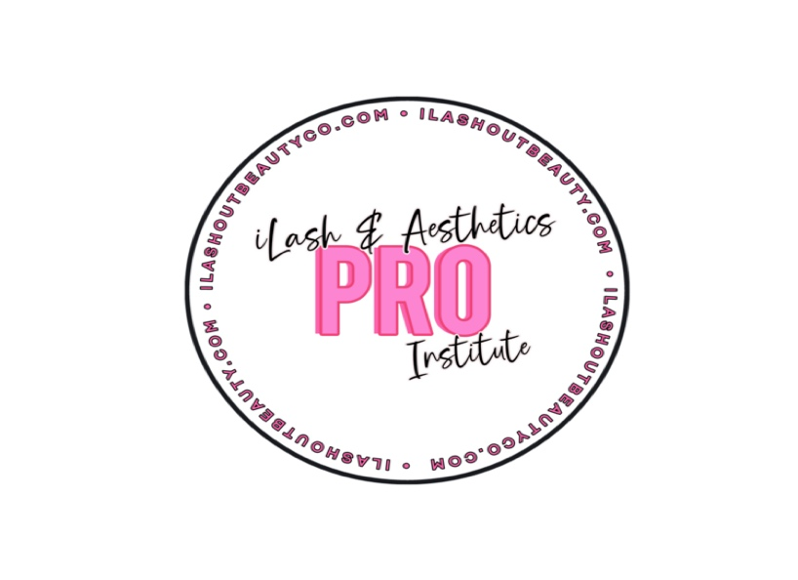

Enrollment Application

Please complete this application and submit with copies of your high school diploma or GED or HSED certiﬁcate, ofﬁcial high school transcripts, driver’s license or state ID card, a letter of intent or short essay (use space provided), and a $25.00
non-refundable application fee. Missing or inaccurate data may result in application being returned as incomplete or may result in denial of your application.
For Ofﬁce Use Only:
Date: Recd By:
$25.00 App Fee Recd: Start Date:

PERSONAL INFORMATION

Full Name: |  | Social Security #:
Present Full Address (include city, state, and zip):
Cell Phone: |  | Home Phone: | Email:
Birth Date: | Age: | Marital Status: | Number of Dependent Children:

EDUCATION: Have you ever attended this or any other Cosmetology School Yes No If yes, please attach ofﬁcial transcripts.

High School or GED/HSED Issuing body (Include name and location): | Date Graduated:
College / Trade School #1 and Major (Include name and location): | Date graduated or withdrew and reason for not completing:
College / Trade School #2 and Major (Include name and location): | Date graduated or withdrew and reason for not completing

EMPLOYERS: Please provide information for your current employer and/or most recent employment.

Employer Name and Phone: | Dates Employed: | Position: | Reason for leaving:
Employer Name and Phone: | Dates Employed: | Position: | Reason for leaving:

Enrollment Application

REFERENCES: Please provide two personal references not related to you, whom you have known at least one year.

Name of Reference #1:

Address of Reference #1
(include city, state, and zip code): Name of Reference #2:
Address of Reference #2
(include city, state, and zip code):
Phone #:

Relationship to Reference #1:

Phone #:
Relationship to Reference #2:

HEALTH INFORMATION: The esthetic industry has demanding physical requirements, including standing and holding your arms at shoulder height for long periods of time, ﬁne motor control and manual dexterity as well as hand and eye coordination. By completing this application you certify that you are capable of meeting the physical requirements of the industry.
Do you have any physical limitations that preclude you from working in the esthetic industry? (please check all that apply) Back Problems Ankle Asthma Arm / Shoulder Wrist Leg
Serious illness in the past ﬁve years:

If you checked any of the above, please explain:
Please write a short essay letting us know why you would like to be in the industry, why you feel you should be considered for acceptance and what your goals are upon completion of the program. Use the space provided below or attach a Letter of Intent.
_______________________________________________________________________________________________________________________

_______________________________________________________________________________________________________________________

_______________________________________________________________________________________________________________________

_______________________________________________________________________________________________________________________

_______________________________________________________________________________________________________________________

CERTIFICATION AND AGREEMENT
Please read carefully: I hereby certify that the facts set forth in the above application are true and complete to the best of my knowledge. I understand that if accepted as a student, falsiﬁed statements on this application shall be considered sufﬁcient cause for dismissal. You are hereby authorized to make any investigation of my personal history and ﬁnancial credit record through any investigation or credit agencies of your choice. I understand that this application is only valid for six months after signing, and that any fees paid will be forfeited thereafter.

Signature: Date:

